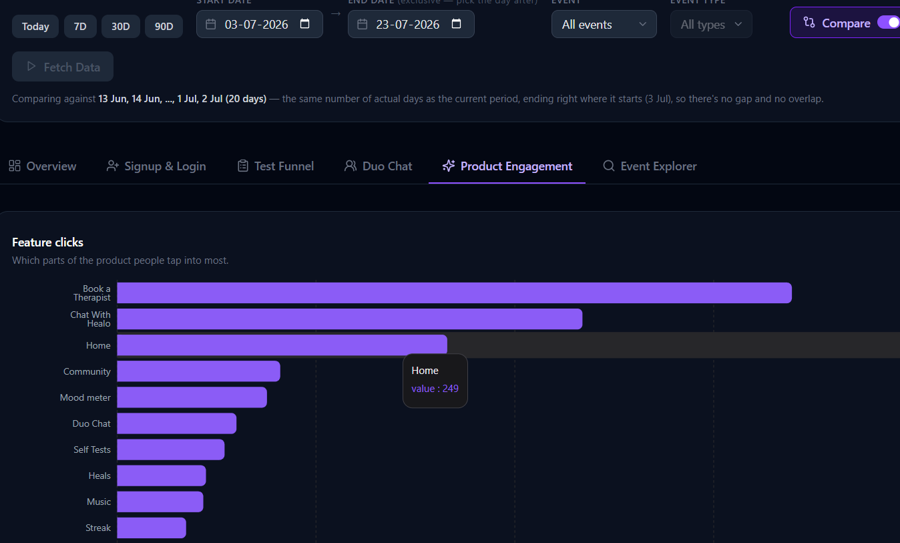
Metric | Jul 17–18 | Jul 18–19 | Jul 19–20 | Jul 20–21 | Jul 21–22 | Jul 22–23
Users who viewed Profile Section | 63 | 7 | 10 | 19 | 34 | 48
Redirected to blogs via Curated for You | 0 | 0 | 1 | 2 | 2 | 4
Redirected to tests via Curated for You | 1 | 0 | 2 | 2 | 0 | 1
Redirected to Healo via Today in your plan | 2 | 1 | 4 | 4 | 5 | 5
Users who clicked Home | 41 | 3 | 8 | 23 | 27 | 32
Avg time on Home (min) | 0.52 | 0.37 | 0.75 | 1.01 | 0.81 | 0.68
Total time on Home (min) | 21.22 | 1.85 | 7.48 | 20.23 | 15.32 | 18.32
Unique Home users | 41 | 5 | w | 20 | 19 | 27

Last one-month analysis: 26 June - 26 July
Stage | Count | % of signups (2,392) | % of prior stage
Total completed signups | 2,392 | 100% | —
Unique Home users | 211 | 8.8% | 8.8%
Home → curated redirect (blog/test, dedup ceiling) | ≤93 | ≤3.9% | ≤44%
Home → Chat via "Today in Your Plan" | 55 | 2.3% | 26%
8.8% of the month's signups are unique Home users in the same window.
Even accounting for the no-cohort-join caveat, that's a steep drop before Home even gets a chance to do its job — meaning most of your funnel loss is happening before Home, not because of anything Home does or doesn't do.
Final Verdict: Homepage is neither working as a user-retaining funnel nor contributing as a product engagement loop. The main reason being, for the majority of our web users (our main channel), entry points and acquisition media are directly tied to self-tests.
Home might never act as a primary acquisition and retention channel due to the type of entry points we created.
Unlike Web, Home page activity and push notifications to re-engage users can actually work well with apps.

